ANN - Backpropagation, Sigmoid, Tanh

* <https://mattmazur.com/2015/03/17/a-step-by-step-backpropagation-example/>
* 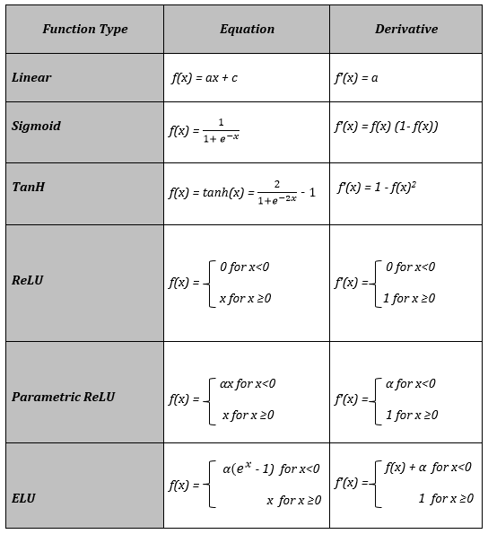

Decision Tree

* <https://www.geeksforgeeks.org/decision-tree-introduction-example/>
* Calculator: <https://planetcalc.com/8443/>

Bagging - Bootstrap Sampling, Random Forest

* <https://machinelearningmastery.com/bagging-and-random-forest-ensemble-algorithms-for-machine-learning/>

Boosting - Boosting by Majority, AdaBoost, XGBoost (only its features)

Bias Variance

* 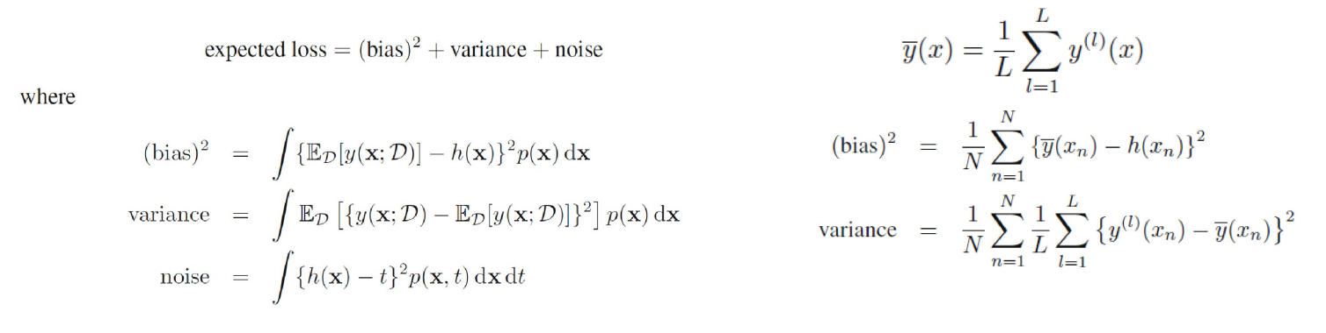

KMeans

* <https://www.geeksforgeeks.org/k-means-clustering-introduction/>

Gaussian Mixture Model

* <https://www.geeksforgeeks.org/gaussian-mixture-model/>